**HAProxy Marathon Bridge Configuration**

Setup steps:

1. Install mesosphere on the machine you want to act as mesos-master. Do the configuration for the master node.
2. Install mesos on the machine you want to act as mesos-slave. Do the configuration required for the slave node.
3. Install HAProxy on both the nodes.

HA Proxy configuration:

After installing haproxy on both the nodes, edit the nano /etc/default/haproxy as:

Set the ENABLED option to 1

ENABLED=1

You need to specify the “listen” block in the /etc/haproxy/haproxy.cfg file as follows:

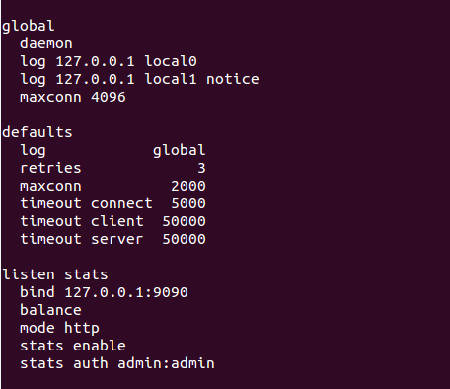

Installing HAProxy marathon bridge

To install the [haproxy-marathon-bridge script](https://github.com/mesosphere/marathon/blob/master/bin/haproxy-marathon-bridge) on each node:

1. Download the haproxy-marathon-bridge script:

wget https://raw.githubusercontent.com/mesosphere/marathon/master/bin/haproxy-marathon-bridge

1. Create a configuration file at /etc/haproxy-marathon-bridge/marathons for the script to use. This should contain the host and port of each running Marathon instance on a new line:

marathon1.company.com:8080

marathon2.company.com:8080

marathon3.company.com:8080

1. Install the script as a cron job by running:

./haproxy-marathon-bridge install_cronjob

1. Restart haproxy service.